**Sample Output :**

./<filename>.sh

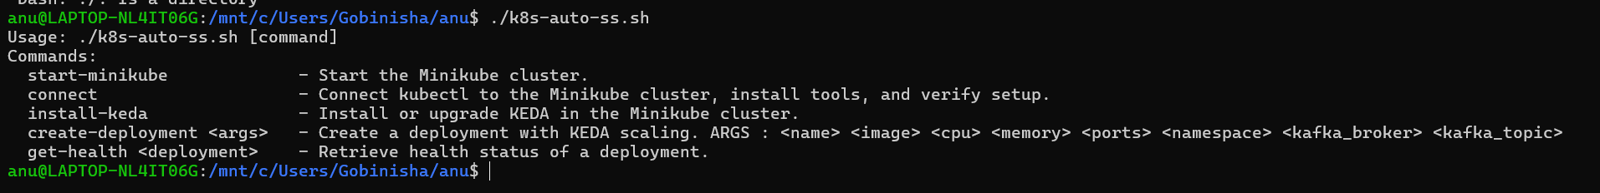

./<filename>.sh start-minikube (this is executed to create a kubernets env in local)

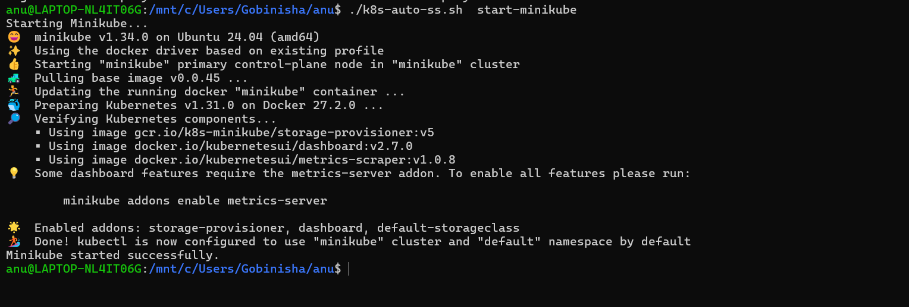

./<filename>.sh connect

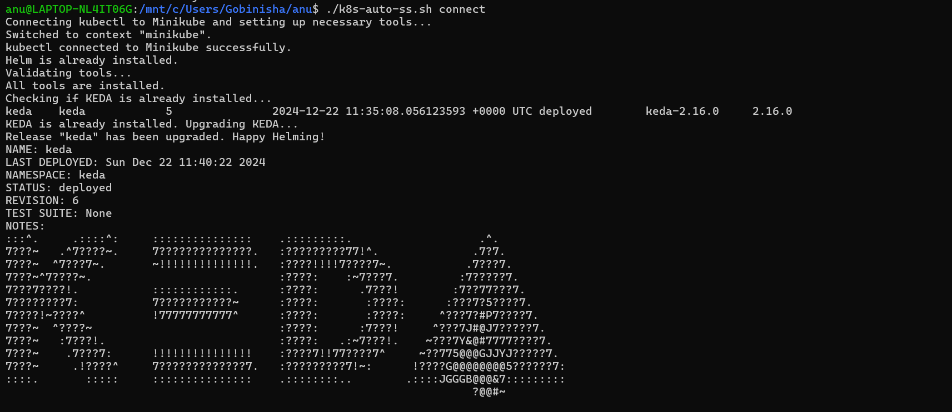

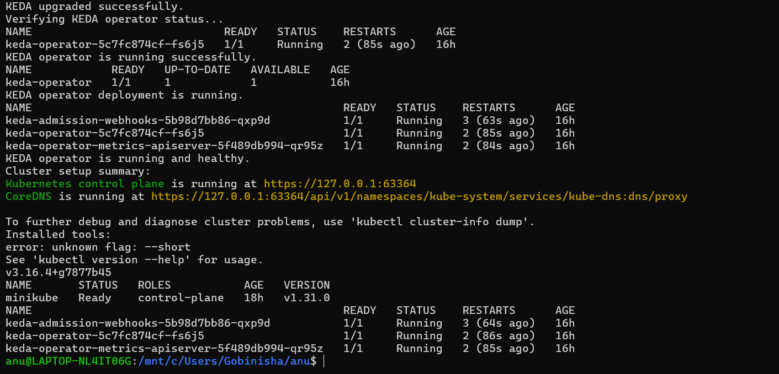

./<filename.sh> create-deployment test-app nginx:1.21.6 200m 256Mi 80 test-ns localhost:9092 test-topic

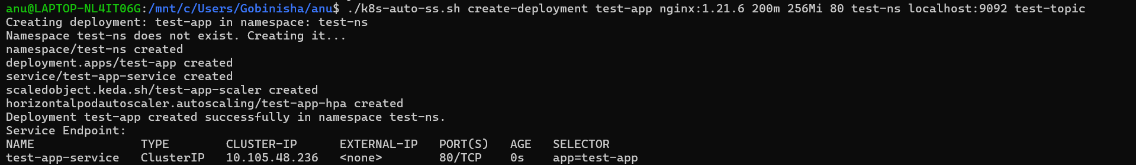



./<filename>.sh get-health <deployment-name> <ns>

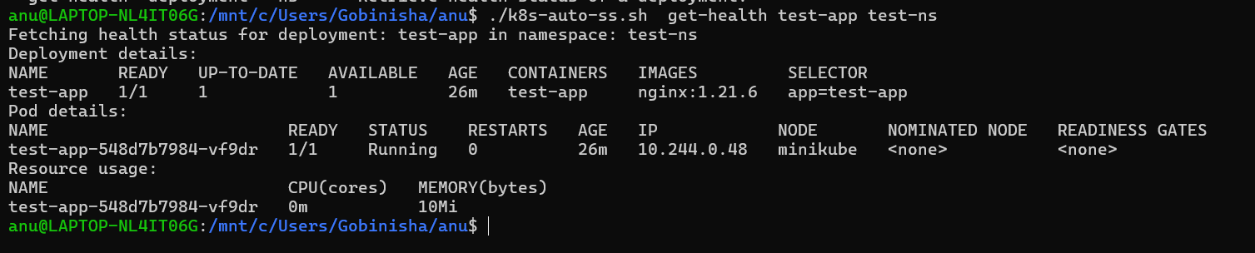

The below block allows to connect to the k8s cluster using kube config.

(usecases other than minikube)

connect_and_setup_cluster() {

echo "Connecting kubectl to the Kubernetes cluster..."

# Assuming kubeconfig file (default or specified with --kubeconfig flag)

KUBECONFIG_PATH="$HOME/.kube/config" # Or specify your custom path

if [ -f "$KUBECONFIG_PATH" ]; then

echo "Using kubeconfig at $KUBECONFIG_PATH"

export KUBECONFIG=$KUBECONFIG_PATH

else

echo "Error: kubeconfig file not found at $KUBECONFIG_PATH"

exit 1

fi

# Test the connection to ensure kubectl is configured correctly

kubectl cluster-info

if [ $? -eq 0 ]; then

echo "kubectl is connected to the Kubernetes cluster."

else

echo "Error: Unable to connect to the Kubernetes cluster."

exit 1

fi

}